**POM FIRST CLASS(MON 13-7-2020) :**

**Three elements of Organization:**

First and foremost element of organization is people

You may call them manager,supervisor,employees,ceo anything kch bhi

Second element that you require to run the organization is a goal.If you donot have anytarget then what you are thinking that how to deal with the people or how to take the work out of people.

Third elemen is the structure of the organization.By structure we mean infrastructure and psychological structure(hearcichy) to those you have to report.Who reports to whom.Kon kia kaam kr rha hai or kise report kr rha hai.

Three level manager:

Top level managers(ceo,chief financial officer Cfo,COO chief operating officer,president,vice president) they are the strategic planners of the organization.

,mid level , HR ,finance,account,supply chain manager(repomsible for their own department)

lowest level(firstline). People taking orders from middle level mnagers. Assisstan manager hr ,Assistant manager finance.

It can be man or woman

**POM Second class 7-15-2020**

Ancient management :

Pyramids and great wall of china (impossible to rebuild)

Adam Smith :

Division of labour(job specialization)

Breakdown the broader jobs into narrower jobs .HE gave the concdpt of scientific management

Industrial Revolution :

Machines were substituted with human labo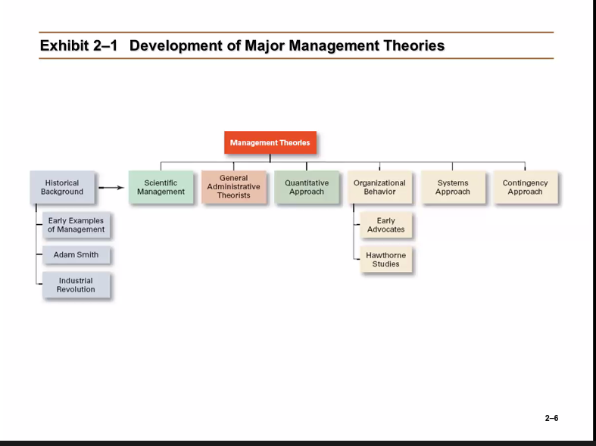r

**Scientific Method :**

**Fredrick W taylor contribution :**

Use one best way approach:

Put right person on the job with the current loads and equipments.

Have standardized method of job.

Provide good econocmic incentive to the worker.

**Taylor’s Four principle**

Old Rule of thumb replace kren (: A method of working (something very very explicit)

Scientifically workers ko train kren

Workers k sth cooperate kren

Kaam divide krden.

**Frank and Gilbert :**

Focused on increasing productivity through the reduction of wasted motion.

They developed a device micro chronometer to optimize the work

**General Administrative Theory :**

**Henry Fayol:**

Practice of management was distinct from organization functions

Developed 14 principles of management.

**Max weber :**

Developed a theory based of bureaucracy

Points of bureaucracy

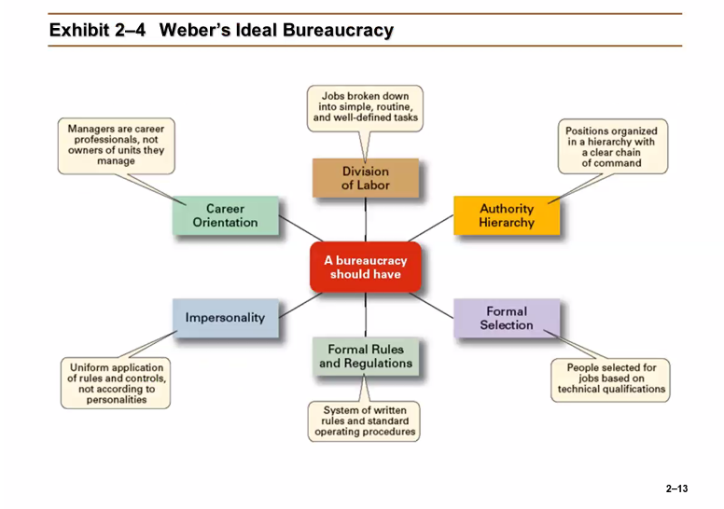Division of labour is a very important point.

**Quantitative Approach to Management :** Quantity (numbers ka khel hai)

It focus on improving managerial decisions by applying statistics,optimization models,computer stimulations and computer stimulations.

**POM Third class (7-20-2020)**

**Omnipotent View of Management :** Managers are responsible for the success and failure of an organization.  
Too see how well organization is going.See their managers.

**Sympbolic View of Management :** Organizational result depends on outside factors Eg : if the economy is low then there is nothing you can do.

If you are a manager then there is minimum role in success and failure.

**Omnipotent or Symbolic :** Managers are neither helpless nor with all powers.

**Culture :** Repesent the organization’s professionalism.It shows the behaviour

**Planning :** In some organizations taking risks is prohibited.

**Organizing :** Degree of freedom to its employee.

**Leading :** Degree of concern for job satisfaction.

**Controlling :** Where you depend on external and internal control,

Internal controls are from boss  
External controls are from environment

How to establish and maintain culture ?

To establish culture first establish values , make selection criteria

**Organizational Culture :**Organization ki personality.Atttributes through which we can describe an organization.A system of shared meanings and common belief held by the organizational members that determines ,in a large degree ,how they act towards each other.

The way we do things around here.  
Values,symbols,rituals,myths,practices.

Culture is a perception,shared,descriptive.

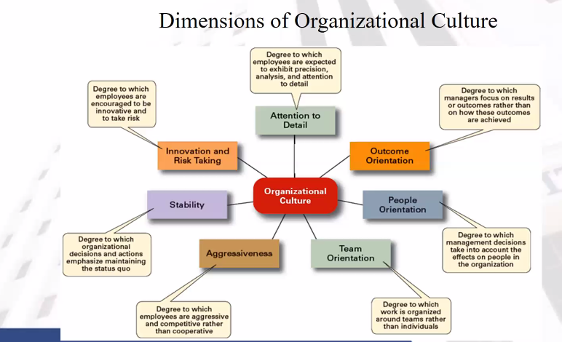

**How culture is developed :**

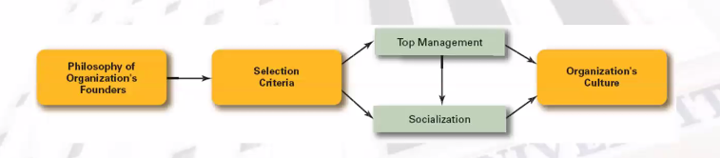

**POM 4th class 7-22-2020**

**Decision making :**

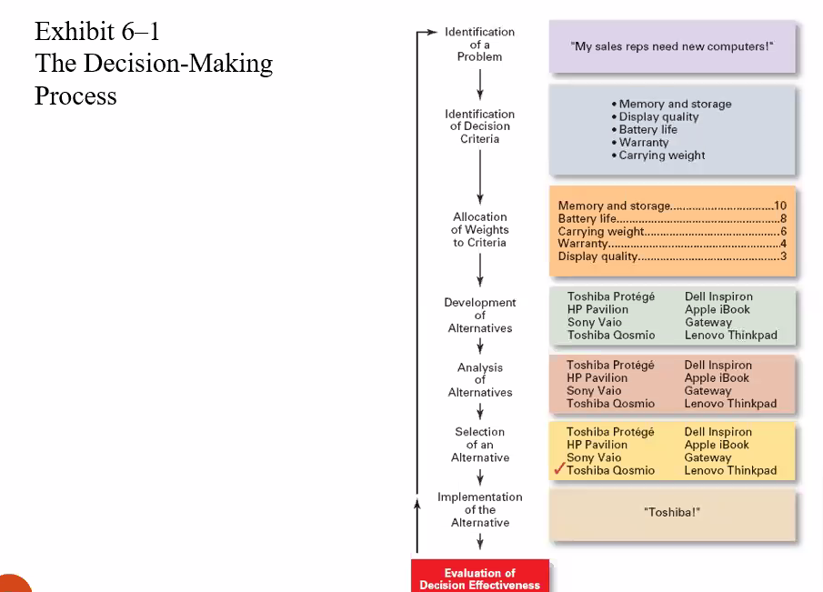

**5th class:**

**Manager as a decision maker :**

**Rational Decision making :** Logical decision lena

**Intuitive Decision making :**  Dil se decision lenaagr ag